title of the PAPER FOR PLMSS 2017

First A. Author¹, Second B. Author² and Third C. Author³

¹Full address of first author, including affiliation, email and website
²Full address of second author, including affiliation, email and website
³Full address of third author, including affiliation, email and website

Keywords:Laminated plates, Harmonic analysis, Finite elements, Reduced Integration

Abstract
The abstract should be entitled with the word ABSTRACT centred, in 11 pt boldface Calibri. One 11pt space must be left after the title. The ABSTRACT should not exceed200 words of text.

1 INTRODUCTION
The papers presented at the ICCMS 2017 will be published in electronic format and made available to the conference participants via the ICCMS 2017 website during and after the conference.

2 GENERAL SPECIFICATIONS
The paper should be written following the format of this template. The file has to be a .docx file. The paper must be written in English and have a length of 10 pages in A4 format (29.7 cm x 21 cm). The text should be written single-spaced, justified, using 12pt Calibri in one column. Margins are 3 cm on the top and 2.5 cm on the bottom, and 2.5 cm on the left and right (printing box of 24.2 cm x 16 cm). Leave one 11pt space between paragraphs.
Presenting authors should upload the full paper in pdf format using the special web-link they will receive upon registration and payment of registration fee via the ICCMS 2017 online submission system.

3 TITLE, AUTHORS, AFFILIATION, KEY WORDS
The first page must contain the Title, Author(s), Affiliation(s), Key words and the Summary. The Introduction must begin immediately below, following the format of this template.

3.1 Title
Title of the paper should be written centred, in 16 pt boldface Calibri, all capital letters.

3.2 Author(s)
Author’s name should include first name, middle initial (if desired) and surname, and be written centred, in 11pt Calibri, 11 pt below the title.

3.3 Affiliation
Author's affiliation should be written centered, in 11pt Times, 11 pt below the list of authors.

3.4 Key words
A maximum of five keywords (beginning with Keywords: boldfaced) should be added, separated by a comma, and written centred, in 11 ptCalibri, a capital being used for the first letter of each keyword. Leave one 11pt space after title, author(s), affiliation(s) and keywords.

3.5 Headers
The header of the second, fourth, sixth etc. (even pages) page should contain the names of the authors (first name, middle initial if desired and surname), and be written centred, in 9pt Calibri.

4 TEXT
The normal text should be written single-spaced, justified, using 11pt Calibri in one column. The first line of each paragraph must be indented 0.5cm.

5 FIGURES AND TABLES
Figures and Tables should be centred, numbered consecutively and captioned. Leave a 11pt space between Figure or Table and corresponding caption. The caption should be written centred, in 11pt Calibri with upper and lower case letters. Two 11pt spaces should separate the upper part of the figure or table and the bottom of the caption from the surrounding text. Examples of a figure (Fig. 1) and a table (Table 1) are given below.

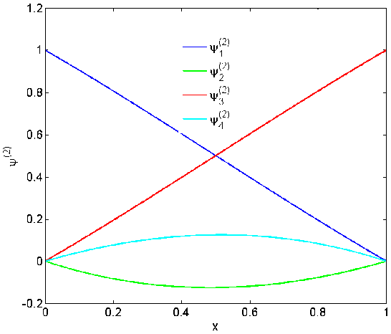
Figure 1: This is an example of a figure.
A 6pt space should separate the figure from the caption, and a 11 pt space should separate the upper part of the figure and the bottom of the caption from the surrounding text.

Engineering constant |  | Identification | Homogenized model
E₁ | [GPa] | 21.7 | 25
E₂ | [GPa] | 20.3 | 25
₁₂ | – | 0.12 | 0.064
G₁₂ | [GPa] | 1.55 | 2.7
tan(E₁) | – | 0.0051 | –
tan(E₂) | – | 0.0062 | –
tan(G₁₂) | – | 0.0098 | –

Table 1: This is the example of a table.

A 6pt space should separate the Table from the caption, and a 11 pt space should separate the table from the surrounding text.Figures and Tables should be included in the text of the Paper.

6 EQUATIONS
A displayed equation is numbered flush right, using Arabic numbers in parentheses. It should be centered, leaving a 6pt space above and below to separate it from the surrounding text.
The following example is a single line equation:
cx = D | (1)
The next example is a multi-line equation:
Qx = b | (2)

8 REFERENCES
The references should be placed at the end of the paper and entitled with the word REFERENCES centred, in 11 pt boldface Calibri. References should be quoted in the text by numbers ([1], [2, 3] or [1-3]) and grouped together in the list of references in numerical order. For the style, please consult the references shown hereafter in a list of references including a journal paper [1], a book [2] and a conference proceeding [3].

9 CONCLUSIONS
The paper should be written following the format of this template. The file has to be translated into Portable Document Format (PDF) before submission. Presenting authors should upload the full paper in pdf format using the special web-link they will receive upon registration and payment of registration fee via the ICCM2017 online submission system www.iccms2017hyd.com no later thanSeptember15 2017. For more information about the instructions for the layout of the paper, please contact the Conference Secretariat via sending email to iccms2017@iith.ac.in

ACKNOWLEDGEMENTS
A paragraph at the end of the paper (before the references) may be added (optional) for acknowledgments. It should be entitled with the word ACKNOWLEDGEMENTS centred, in 11 pt boldface Calibri.

REFERENCES
[1] B. N. Rao and M. Kuna: Interaction Integrals for Fracture Analysis of Functionally Graded Piezoelectric Materials, International Journal of Solids and Structures, 45, 2008, pp. 5237 – 5257.
[2] K. K. Singh and C. N. Babu, Finite element analysis of composite laminates, Solid Mechanics and its Applications, Vol. 7, Kluwer Academic Publishers, Dordrecht, 1992.
[3] L. Dumal, T. Golmal and J. Kumal, Delamination propagation measurement using long gauge-length FBG sensors, Proceedings of the 23rd International Conference on Composites Testing and Manufacturing CTM 2017 (Eds. P. Camanho, F. Pierron, M. Wisnom), Porto, Portugal, April 10-12, 2006, University Press, Porto, Paper 41, 2006, pp. 174-175.

